A Mini Project On
ONLINE QUIZ
Department Of Information Technology
Submitted By
Batch:16
k.Narasimha sai 17121a1246
k.Sushma 17121a1247
k.chandana 17121a1248

SREE VIDYANIKETHAN ENGINEERING COLLEGE
(AUTONOMOUS)
(Affiliated to JNTUA, Ananthapuram, Approved by AICTE, Accredited by NBA & NAAC)
Sree Sainath Nagar, Tirupati – 517 102, A.P., INDIA
2018 -2019

TABLE OF CONTENT

S. No. TITLE Pg.No.

Abstract
1. Introduction 1
2. Project Details 2-3
3. Hardware and software requirements 4
4. Design of project 5-8
5. Source Code 9-19
6. Output 20-22
7. Conclusion 23
Reference to project

ABSTRACT
Main objective:-

To efficiently evaluate the candidate thoroughly through a fully automated system that not only saves lot of time but also gives fast results.
This system asks student to register with his/her name and also with the respective ID number given to each. Also ask to set a very strong password for security and for future reference. Before each student start their exam this application will ask to enter their ID number and password for conformation purposes. If the student entered their ID number with the correct password then they start the exam. If any had entered wrong password then the application immediately inform that the student had entered wrong password. To make the student convenient it shows the option like retry and change password.
If the student wants to try again then have to press the respective number given to it. Also can change the password for this it ask to re-enter the student ID number and give a chance to set the new and strong password. After the exam is completed the score will be shown right there itself.
With this application the student can test their ability easily and can improve themselves. Can get good attention and interest with the subject and exam.
In future this application can be developed with voice recording answers for very big question not only to the multiple choice questions. Every student has necessity to test their ability and correct their mistakes for their repairs and enhancements. So this application helps to update the student easily.

INTRODUCTION

In this project, we store the questions, choices and correct answer into a file. The student details who are registered are stored in another file.The students who are registered and completed their exam and got a score, those students details and their score is stored into an another file.
This application starts with registration the students who are registered only can attempt the exam. If the student doesn’t know this and came to attempt the exam then they can register there itself and continue the exam right there. For acknowledgement purposes this system asks the student to enter the ID number and password (i.e.,) to know who is going to attempt this exam. Also to store their score with respect to that student.
If the student enters the wrong password then it will ask to retry or change the password and continue the exam.System asks the user to enter his/her name and also asks him whether he/she ready to participate in the quiz or not. If he/she is ready to participate it display the message like each question carries 10marks and wrong answer carries 0marks. And which the student ALL THE BEST before they get started.
Questions followed by four choices are displayed and asks user to enter any one choice.If the entered choice matches the correct answer.. then score incremented by 10 or else it's displays choice entered is wrong.. and displays correct answer.
This process continues until the last question and then displays the score of student got. Also the student can check for the students who attempted the same question paper and also watch their score later also.

PROJECT DETAILS

Modules:-
In total there are three modules. They are:-
- Registration.
- Participation.
- Display Score.

2.1. Registration Module :-
The main objective for Registration module is to register the student details.The student have to enter his/her full name, their respective ID number and also have to set a strong password. At the same time we can register the more than one student details.
This module was built to take the input from the users. That is their details like the user ID number of student, student name and a strong password is recommended to stay their details safe.

2.2. Participation Module:-
The main objective for the Participation module is to start exam. The student can’t start the exam unless they got registered first. If they student want to register right here from the participation module they can do that also. The system asks to press the respective key to register and also to start exam. After this the student will be asked to enter their ID number and the password. If it matches then the questions will be displayed otherwise. The student is asked to retry or change password. After completing the password issues the exam will be started. Once the questions are started correct answer will get ten marks incremented and for wrong answer zero marks and correct answer will be displayed right there. At the end the score is displayed.

This module was completely made to start the exam by the users strictly who are registered. If in case the student came to exam without registration they will be asked to give their information like the ID number, student name and a strong password. If the user got registered then they are asked to enter their ID number and password. If they entered right then question got displayed to start their exam. If wrong then asked to change or retry the password. After getting set the student can start exam.
The question number, question and four options are displayed then student is asked to enter the option number which they think as correct answer. If the answer is correct then a message is displayed right over there that it is a correct answer. Otherwise it displays a message like wrong answer and also shows the correct option right there. To make the student correct on the spot

2.3. Dispaly Score Module :-
The main objective for the display score module is to display the marks of the students. Here every one can watch their score. And separate modules are kept to see the students who got score more than thirty and less than or equal to thirty.
This module takes the input for the display of student marks. The user can watch the score of all the students, less than or equal to 30marks and greater the 30marks of students separately. Then the student name, student ID number and marks of the student obtained will be displayed.

Hardware and Software Requirements

Minimum Software Requirements:-
->Ubuntu 14.04.5 LTS is required to run the application.
->Linux operating system
Minimum Hardware Requirements:-
->4GB RAM and 1TB Hard disk is more than enough to execute and run this application.
->32-bit or 64-bit processor is needed to fetch, decode and execute the instructions.

DESIGN OF PROJECT
Flow of main menu
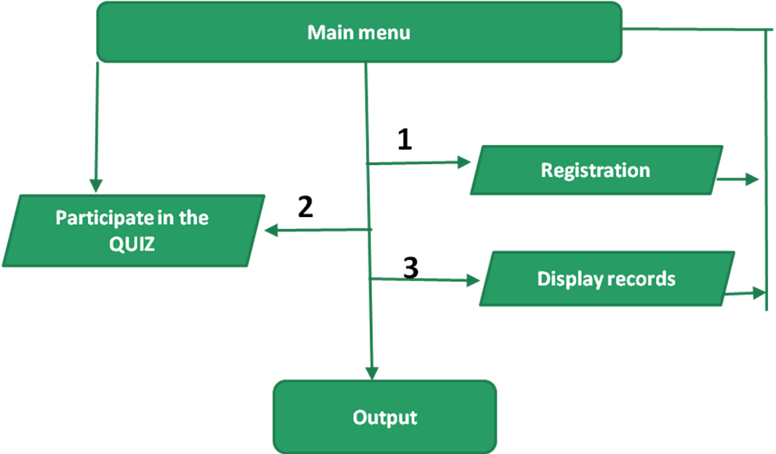

The main menu displays the modules present in the application and takes the input from the user like the module number which they want to execute.

Flow of Registration module

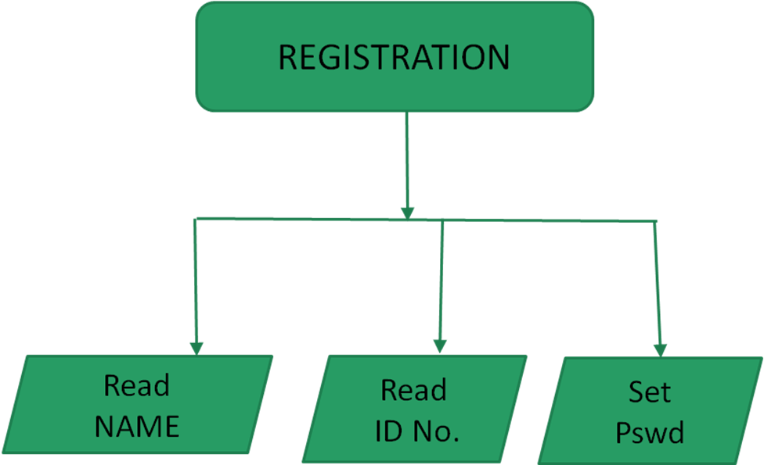

In the registration module the user is requested to enter their full name, ID number and set a strong password to register.

Flow of Participation module

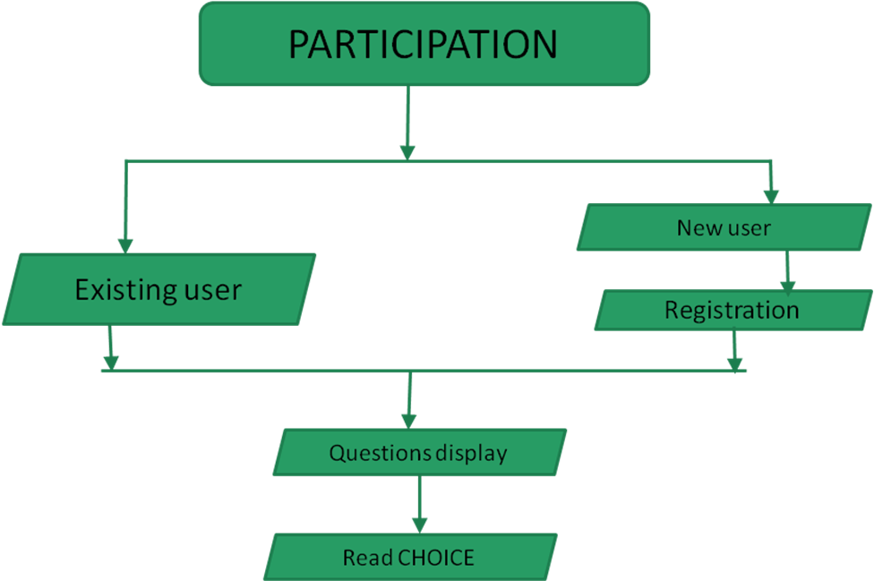

In participation module the existing user can start the exam and the new user have to register to start the exam. The application starts displaying questions with four options and ask to choose the one option among them. At the end the score is displayed.

Flow of Display Records module

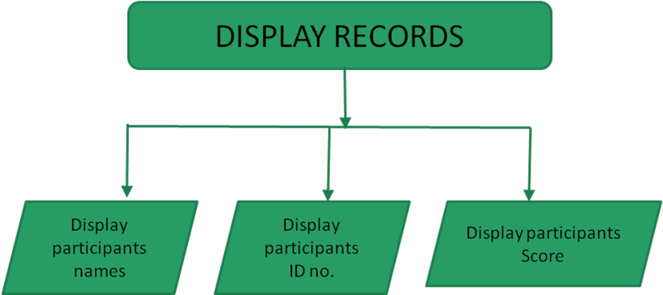

The score is displayed with the student name, ID number and the score the respective student obtained in the exam.

Source Code

#include<stdio.h>
#include<stdlib.h>
#include<string.h>
struct questions
{
int qno;
char question[60];
char op1[19];
char op2[19];
char op3[19];
char op4[19];
int answer;
};
struct questions q1;
struct student
{
char name[19];
char idnumber[19];
char password[19];
double score;
};
struct student s1;
void startexam(void);
void getquestions()
{
int c=1;
FILE *fp;
fp=fopen(“questions.txt”,”a+”);
while(c==1)
{
printf(“Enter question number\n”);
scanf(“%d”,&q1.qno);
printf(“Enter the question\n”);
scanf(“%[^\t]”,q1.question);
printf(“Enter the four options\n”);
scanf(“%s %s %s %S “,q1.op1,q1.op2,q1.op3,q1.op4);
printf(“Enter the answer option number\n”);
scanf(“%d”,&q1.answer);
fwrite(&q1,sizeof(q1),1,fp);
printf(“Do you want to enter another question? 1.yes 2.No\n”);
scanf(“%d”,&c);
}
fclose(fp);
}

void registration()
{
int c=1;
FILE *fp;
fp=fopen(“student.txt”,”a+”);
while(c==1)
{
printf(“Enter your name\n”);
scanf(“%s”,s1.name);
printf(“Enter your ID number\n”);
scanf(“%s”,s1.idnumber);
printf(“Enter the password you like\n”);
scanf(“%s”,s1.password);
fwrite(&s1,sizeof(s1),1,fp);
printf(“Is there any other student to register? 1.yes 2.No \n”);
scanf(“%d”,&c);
}
fclose(fp);
}

void changeapassword()
{
long c;
char id[19],pass[19];
FILE *fp=fopen(“student.txt”,”r+”);
printf(“Please re-enter your ID again\n”);
scanf(“%s”,id);
printf(“Set your new password\n”);
scanf(“%s”,pass);
while((fread(&s1,sizeof(s1),1,fp))>0)
{
if(!strcmp(s1.idnumber,id))
{
strcpy(s1.password,pass);
c=ftell(fp)-sizeof(s1);
fseek(fp,c,0);
fwrite(&s1,sizeof(s1),1,fp);
break;
}
}
fclose(fp);
printf(“\nTry now and start your exam\n”);
}

void writeexam()
{
int ch,ch1;
printf(“Are you registered?\n\t1.press 1 if you want to Register now\n\t2.Press 2 if you are ready to start exam\n”);
scanf(“%d”,&ch);
if(ch==1)
{
registration();
printf(“Are you ready to start the exam\n\t1.yes\t2.No\n”);
scanf(“%d”,&ch1);
if(ch1==1)
startexam();
else
return;
}
if(ch==2)
startexam();
}

void startexam()
{
16n tans,counter=0,count=0,change;
char id[19],p[19];
FILE *qp,*sp,*mp;
qp=fopen(“questions.txt”,”r”);
sp=fopen(“student.txt”,”r+”);
mp=fopen(“marks.txt”,”a+”);
if(sp==NULL)
printf(“Error in student.txt file”);
do
{
if(change==2)
sp=fopen(“student.txt”,”r+”);
rewind(qp);
rewind(sp);
printf(“Enter your ID number\n”);
scanf(“%s”,id);
printf(“Enter your password\n”);
scanf(“%s”,p);
while((fread(&s1,sizeof(s1),1,sp))==1)
{
if((!strcmp(s1.idnumber,id))&&(!strcmp(s1.password,p)))
{
printf(“\nEach question carries 10marks, for wrong answer 0marks.\nALL THE BEST\n”);
while((fread(&q1,sizeof(q1),1,qp))>0)
{
printf(“\n”);
printf(“%d . %s\n”,q1.qno,q1.question);
printf(“1)%s\n”,q1.op1);
printf(“2)%s\n”,q1.op2);
printf(“3)%s\n”,q1.op3);
printf(“4)%s\n”,q1.op4);
printf(“Enter your answer\n”);
scanf(“%d”,&ans);
if(ans==q1.answer)
{
printf(“RIGHT ANSWER !!...\n”);
count=count+1;
}
else
{
printf(“WRONG ANSWER !!...\n”);
printf(“CORRECT ANSWER ::%D\n”,q1.answer);
}
}
counter=1;
s1.score=count*10;
printf(“------------------------\n”);
printf(“\nYOUR SCORE IS :: %f\n”,s1.score);
printf(“------------------------\n”);
fwrite(&s1,sizeof(s1),1,mp);
}
}
if(counter==1)
break;
if(counter==0)
{
printf(“\n\nSorry! Wrong password or ID number\n1.To retry\n2.To change password\n3.To quit\n\n”);
scanf(“%d”,&change);
if(change==2)
{
fclose(sp);
changeapassword();
}
if(change==3)
{
return;
}
}
}while(change==1||change==2);
fclose(qp);
fclose(sp);
fclose(mp);
}

void watchscore()
{
int sh;
FILE *fp;
while(1)
{
printf(“\n_____________________________________\n”);
printf(“1.All students\n2.students how got more than 30\n3.students how got less than or equal to 30\n0.exit\n”);
printf(“Enter your choice\n”);
printf(“____________________________________________\n”);
scanf(“%d”,&sh);
switch(sh)
{
case 1:fp=fopen(“marks.txt”,”r”);
while((fread(&s1,sizeof(s1),1,fp))>0)
{
printf(“Student ID number : %s\n”,s1.idnumber);
printf(“Student name : %s\n”,s1.name);
printf(“Student score : %f\n”,s1.score);
}
fclose(fp);
break;

case 2:fp=fopen(“marks.txt”,”r”);
while((fread(&s1,sizeof(s1),1,fp))>0)
{
if(s1.score>30)
{
printf(“Student ID number : %s\n”,s1.idnumber);
printf(“Student name : %s\n”,s1.name);
printf(“Student score : %f\n”,s1.score);
}
}
fclose(fp);
break;

case 3:fp=fopen(“marks.txt”,”r”);
while((fread(&s1,sizeof(s1),1,fp))>0)
{
if(s1.score<=30)
{
printf(“Student ID number : %s\n”,s1.idnumber);
printf(“Student name : %s\n”,s1.name);
printf(“Student score : %f\n”,s1.score);
}
}
fclose(fp);
break;

case 0 :break;
default: printf(“Enter a valid choice\n”);
break;
}//end of switch
if(sh==0)
break;
}//end of while
}

int main()
{
int ch;
while(1)
{
printf(“==================================\n”);
printf(“1.registration\n2.start exam\n3.watch the score\n0.exit\n”);
printf(“Enter your choice\n”);
printf(“==================================\n”);
scanf(“%d”,&ch);
switch(ch)
{
case 1 : registration();
break;
case 2 : writeexam();
break;
case 3 : watchscore();
break;
case 5 : getquestions();
break;
case 0 : printf(“\n*****************THANK YOU*******************\n”);
exit(0);
default:printf(“Invalid choice, try again!\n”);
break;
}
}
}

OUTPUT
Result:

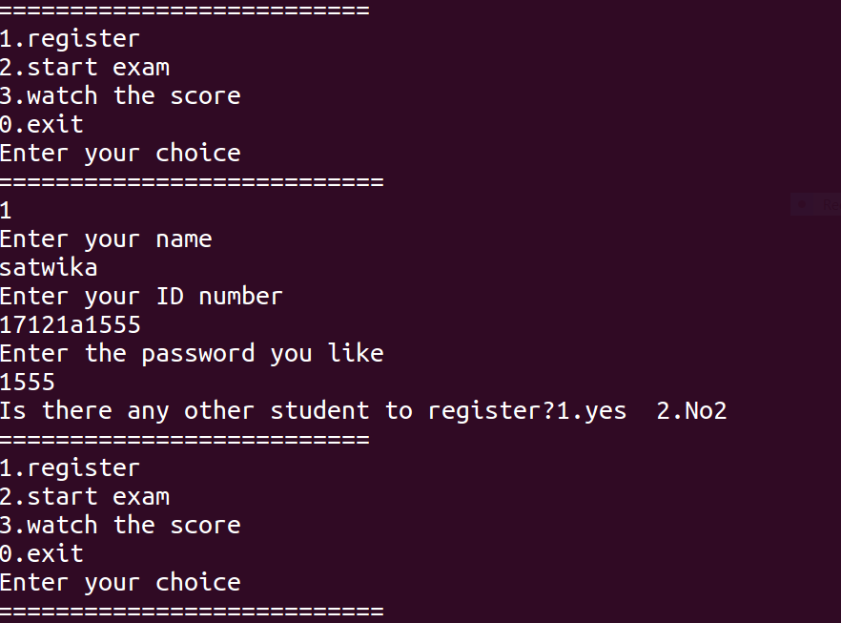
Fig. 2.1 Main menu and Registration

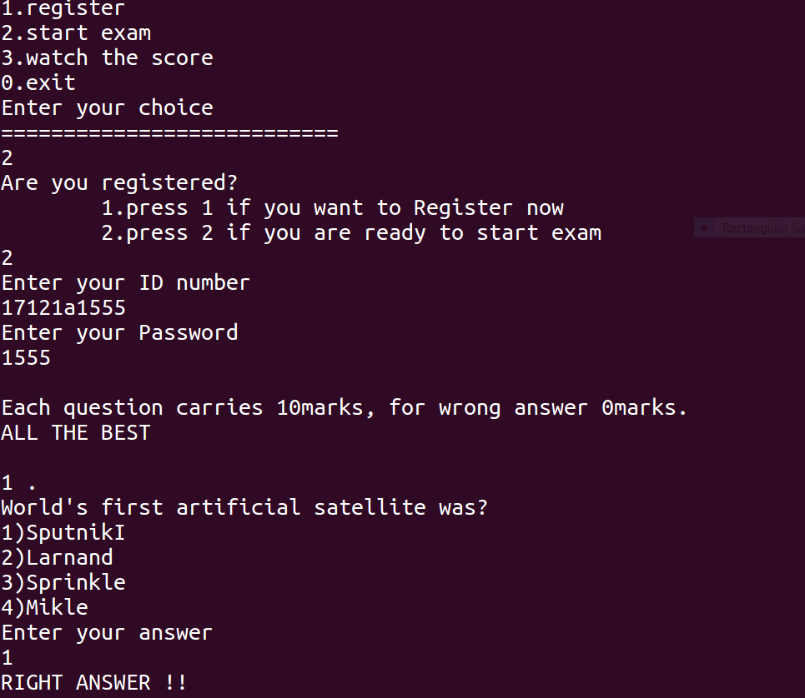
Fig. 2.2.1. Output for Participation
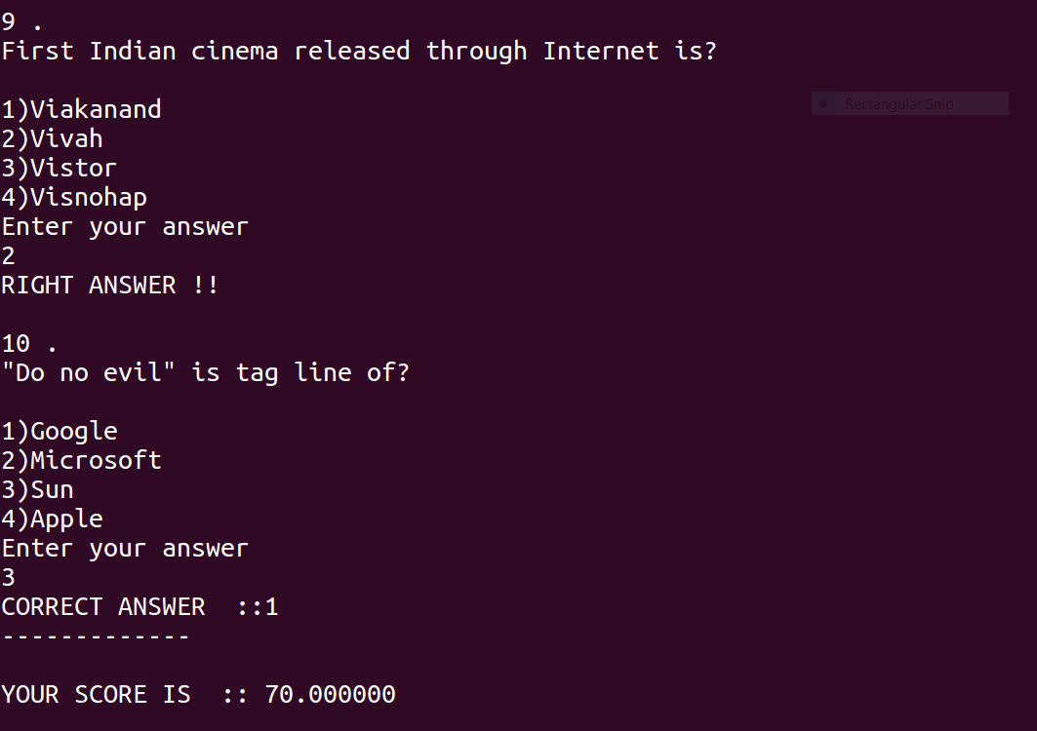
Fig. 2.2.2. Output for Participation

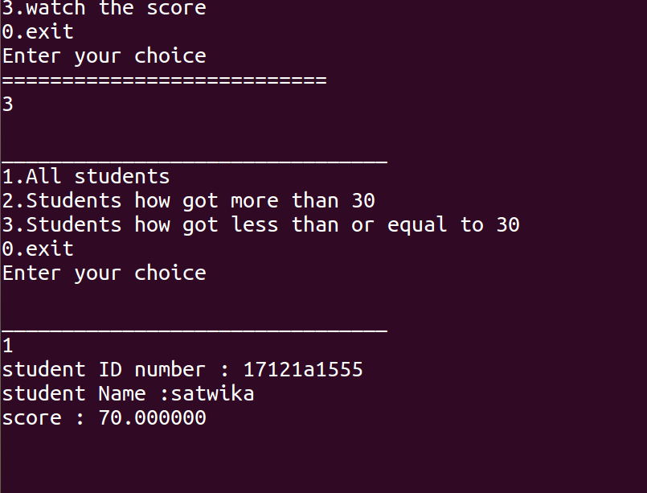
Fig. 2.3. Output for Display Records

CONCLUSION

Final conclusion i.e., OUTPUT is the total score obtained by the participants, their Names including their ID numbers

REFERENCE TO PROJECT

THE C PROGRAMMING LANGUAGE
*Neil Matthew and Richard Stones,
Beginning Linux
Programming, Wiley Dreamtech, Fourth Edition, 2008.

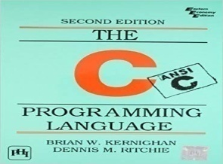

✓Software downloaded Website is
https://www.ubuntu.com/#download.
[02/10/2018]

